Name:= Purva Tagde PRN NO:= 23070521111

Subject:= DBMS LAB

**Practical 3: Part 5:**

# Conversion Function in SQL

In SQL **data type conversion** is important for effective **database management** and accurate query results. Data type conversion ensures that data from different sources or columns can be correctly interpreted and manipulated, especially when dealing with different formats like **numbers**, text, **dates**, and other data types.

**Types of Data Type Conversion in SQL**

There are two main types of data type conversion in SQL.

* **Implicit Data Type Conversion:** This is done automatically by the database management system (**DBMS**) when SQL operations involve columns of different data types. For instance, a **string** value might automatically be converted into a **numeric type** if required by a mathematical operation.
* **Explicit Data Type Conversion:** This is done by the user, who specifies the conversion. This is necessary when SQL cannot automatically convert between data types, or when more control over the conversion is needed.

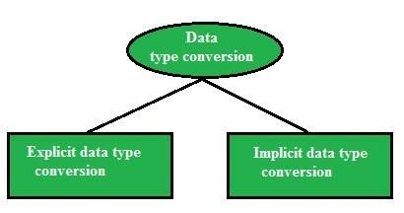

## 1. Overview of Conversion Functions

|  |  |  |  |
| --- | --- | --- | --- |
| **Function** | **Oracle (SQL*Plus)** | **MySQL** | **Description** |
| TO_CHAR() | Yes | ❌ No | Converts a date/number to a string |
| TO_DATE() | Yes | ❌ No | Converts a string to a date |
| TO_NUMBER() | Yes | ❌ No | Converts a string to a number |
| CAST() | Yes | Yes | Converts from one data type to another |
| CONVERT() | ❌ No | Yes | Converts string from one character set to another |
| FORMAT() | ❌ No | Yes | Formats numbers with decimal places |
| STR_TO_DATE  () | ❌ No | Yes | Converts a string to a date |
| DATE_FORMAT  () | ❌ No | Yes | Formats a date as a string |
| TIME_FORMAT  () | ❌ No | Yes | Formats time values |
| UNIX_TIMEST  AMP() | ❌ No | Yes | Converts a date to Unix timestamp |
| FROM_UNIXTI  ME() | ❌ No | Yes | Converts Unix timestamp to a date |

### 2. Conversion Functions in SQL*Plus (Oracle) /skip if you want to use mysql platform

Oracle provides TO_CHAR(), TO_DATE(), TO_NUMBER(), and CAST() for conversion.

#### 2.1 TO_CHAR() – Convert Date/Number to String

**Use Case:** Format **date & time** into a human-readable string.

SELECT TO_CHAR(SYSDATE, 'YYYY-MM-DD HH24:MI:SS') AS formatted_date FROM dual;

**Output Example:**

formatted_date

-------------------

2025-01-29 14:35:50

**Format Number as Currency:**

SELECT TO_CHAR(12345.67, 'L99,999.99') AS formatted_currency

FROM dual;

**Output Example:**

formatted_currency ------------------

$12,345.67

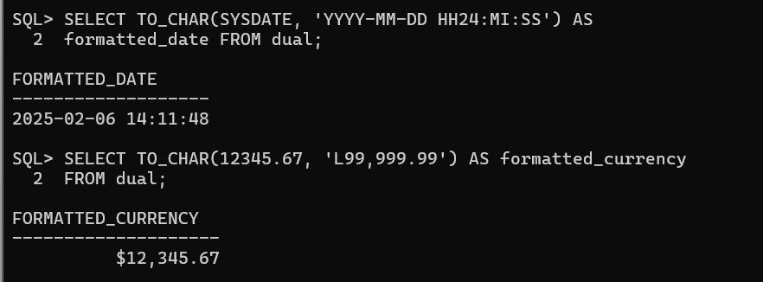

#### 2.2 TO_DATE() – Convert String to Date

**Use Case:** Convert a **string** into a **date format**.

SELECT TO_DATE('2025-01-29', 'YYYY-MM-DD') AS converted_date

FROM dual;

**Output Example:**

converted_date ---------------

29-JAN-25

**Using Different Date Formats:**

SELECT TO_DATE('29-01-2025', 'DD-MM-YYYY') FROM dual;

Sample

output

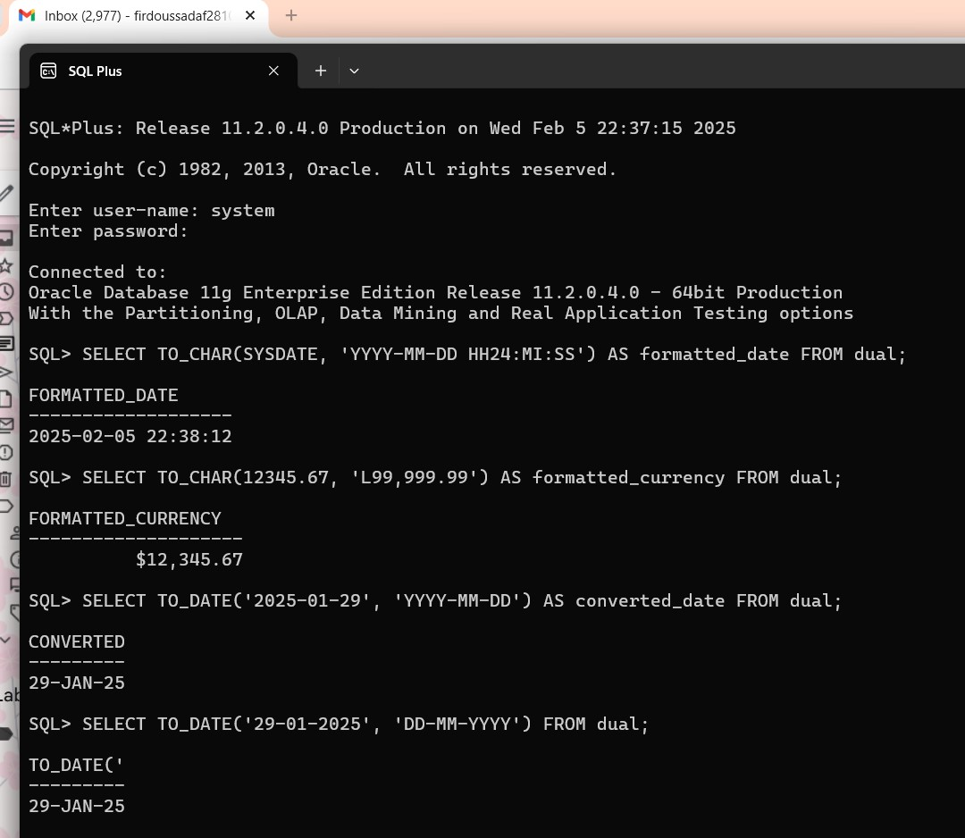

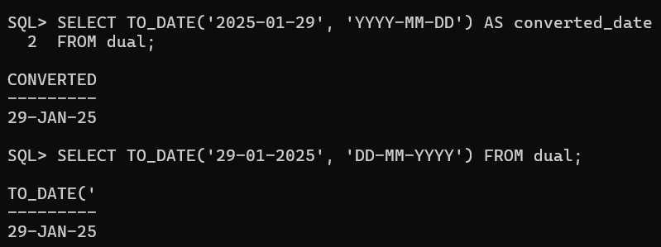

#### 2.3 TO_NUMBER() – Convert String to Number

**Use Case:** Convert a **string** containing numbers into a **numeric type**.

SELECT TO_NUMBER('12345.67') AS number_value FROM dual;

**Output Example:**

number_value ------------

12345.67

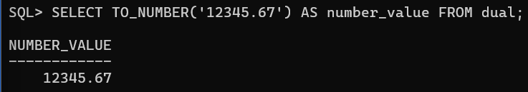

#### 2.4 CAST() – Convert Data Types

**Use Case:** Convert a number to a string or vice versa.

SELECT CAST(123.45 AS VARCHAR2(10)) AS string_value FROM dual;

**Output Example:**

string_value ------------

123.45

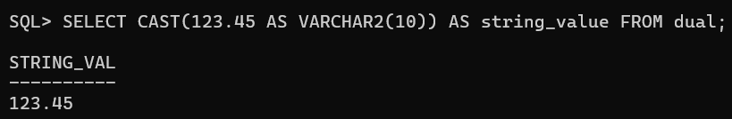

**Convert String to Date:**

SELECT CAST(TO_DATE('2025-01-29', 'YYYY-MM-DD') AS DATE) FROM dual;

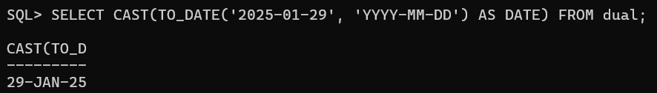

### 3. Conversion Functions in MySQL //SKIP IF DONE WITH

**ORACLE SQLPLUS**

MySQL provides CAST(), CONVERT(), STR_TO_DATE(), DATE_FORMAT(),

etc.

#### 3.1 CAST() – Convert Data Types

**Use Case:** Convert an integer to a **string**.

SELECT CAST(12345 AS CHAR) AS string_value;

**Output Example:**

diff

string_value ------------

12345

**Convert a String to an Integer:**

SELECT CAST('12345' AS SIGNED) AS number_value;

#### 3.2 CONVERT() – Convert Between Character Sets

**Use Case:** Change **character encoding**.

SELECT CONVERT('Héllo' USING utf8mb4) AS utf8_text;

**Convert a Number to String:**

SELECT CONVERT(12345, CHAR) AS string_value;

#### 3.3 FORMAT() – Format Number with Commas

**Use Case:** Display **large numbers with commas**.

SELECT FORMAT(1234567.89, 2) AS formatted_number;

**Output Example:**

diff

formatted_number

----------------

1,234,567.89

#### 3.4 STR_TO_DATE() – Convert String to Date

**Use Case:** Convert **string into date format**.

SELECT STR_TO_DATE('29-01-2025', '%d-%m-%Y') AS converted_date;

**Output Example:**

diff

converted_date ---------------

2025-01-29

#### 3.5 DATE_FORMAT() – Format a Date as a String

**Use Case:** Display **formatted dates**.

SELECT DATE_FORMAT(NOW(), '%W, %M %d, %Y') AS formatted_date;

**Output Example:**

diff

formatted_date

-----------------------

Tuesday, January 29, 2025

#### 3.6 TIME_FORMAT() – Format Time

**Use Case:** Convert **24-hour time** into **12-hour format**.

SELECT TIME_FORMAT('14:35:50', '%h:%i %p') AS formatted_time;

**Output Example:**

diff

formatted_time ---------------

02:35 PM

#### 3.7 UNIX_TIMESTAMP() – Convert Date to Unix Timestamp

**Use Case:** Store dates as **timestamps**.

SELECT UNIX_TIMESTAMP('2025-01-29 14:35:50') AS unix_time;

**Output Example:**

unix_time ----------

1740792950

#### 3.8 FROM_UNIXTIME() – Convert Unix Timestamp to Date

**Use Case:** Convert **timestamps** back to a **date**.

SELECT FROM_UNIXTIME(1740792950) AS converted_date;

**Output Example:**

converted_date ---------------

2025-01-29 14:35:50

### 4. Real-World Use Cases of Conversion Functions

#### Financial Data Reporting

Convert salary figures into **formatted currency**.

SELECT emp_id, TO_CHAR(salary, 'L99,999.99') AS formatted_salary FROM employees;

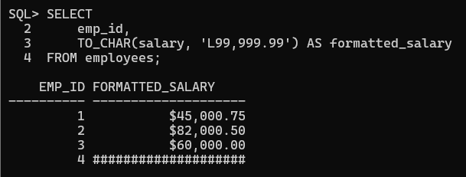

#### Log Analysis (MySQL)

Convert timestamps into **human-readable format**.

SELECT FROM_UNIXTIME(UNIX_TIMESTAMP()) AS current_time;

#### Data Migration

When migrating from **CSV files**, convert **strings to dates**.

SELECT STR_TO_DATE('29-01-2025', '%d-%m-%Y') AS converted_date;

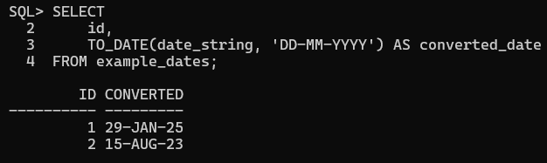

## 5. Summary Table

**Function** **Oracle MySQ Purpose**

**(SQL*Plus)** **L**

TO_CHAR() Yes ❌ No Convert date/number to

string

TO_DATE() Yes ❌ No Convert string to date

|  |  |  |  |
| --- | --- | --- | --- |
| TO_NUMBER(  ) | Yes | ❌ No | Convert string to number |
| CAST() | Yes | Yes | Convert between data types |
| CONVERT() | ❌ No | Yes | Convert between character sets |
| FORMAT() | ❌ No | Yes | Format number with commas |
| STR_TO_DAT  E() | ❌ No | Yes | Convert string to date |
| DATE_FORMA  T() | ❌ No | Yes | Format a date as a string |
| TIME_FORMA  T() | ❌ No | Yes | Format time values |
| UNIX_TIMES  TAMP() | ❌ No | Yes | Convert date to Unix timestamp |
| FROM_UNIXT  IME() | ❌ No | Yes | Convert Unix timestamp to date |

**Advanced Real-World Use Cases of Conversion Functions in MySQL & SQL*Plus (Oracle)**

## 1⃣ E-Commerce: Converting Prices for Different Currencies

**Scenario:** An e-commerce site needs to convert prices from USD to INR and format them properly.

**Oracle (SQL*Plus):**

SELECT product_id, product_name,

TO_CHAR(price_usd * 83.50, 'L99,999.99') AS price_inr

FROM products;

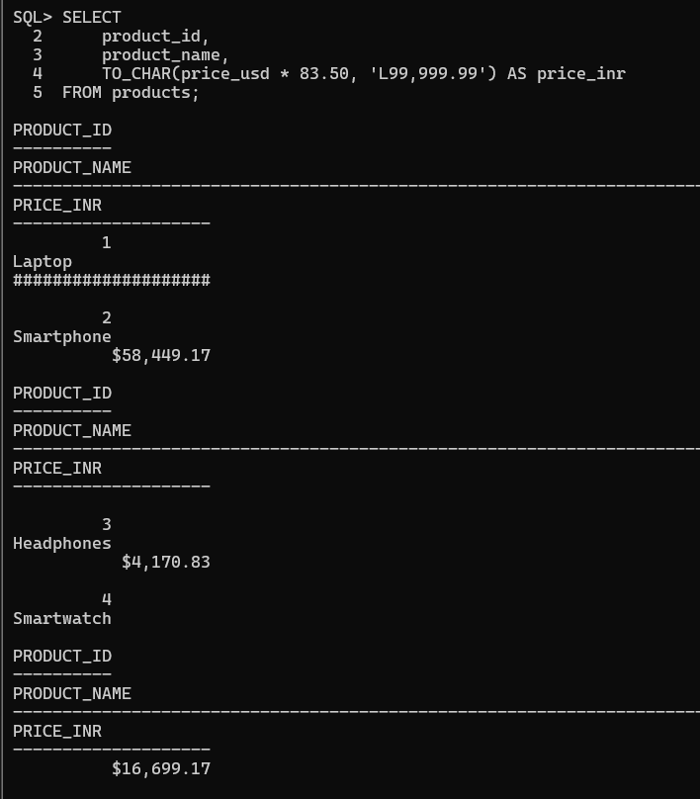

**MySQL:**

SELECT product_id, product_name,

FORMAT(price_usd * 83.50, 2) AS price_inr

FROM products;

**Why?**

* Uses TO_CHAR() in Oracle and FORMAT() in MySQL to **add currency formatting**.
* 1 USD = **83.50 INR** (exchange rate example).

**Example Output:**

|  |  |  |
| --- | --- | --- |
| **product_id** | **product_name** | **price_inr** |
| 101 | iPhone 15 | ₹99,999.99 |
| 202 | MacBook Pro | ₹2,19,999.99 |

## 2⃣ Banking: Detecting Fraudulent Transactions Using Date Conversions

**Scenario:** A bank flags **suspicious transactions** that happened at **odd hours (midnight to 4 AM)**.

**Oracle (SQL*Plus):**

SELECT transaction_id, account_id, amount,

TO_CHAR(transaction_time, 'HH24:MI') AS transaction_hour

FROM transactions

WHERE EXTRACT(HOUR FROM transaction_time) BETWEEN 0 AND 4;

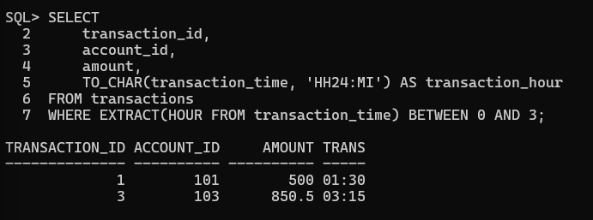

**MySQL:**

SELECT transaction_id, account_id, amount,

TIME_FORMAT(transaction_time, '%H:%i') AS transaction_hour

FROM transactions

WHERE HOUR(transaction_time) BETWEEN 0 AND 4;

**Why?**

* Uses TO_CHAR() (Oracle) and TIME_FORMAT() (MySQL) to **extract and format time**.
* Filters transactions **between 00:00 and 04:00**.

**Example Output:**

|  |  |  |  |
| --- | --- | --- | --- |
| **transaction_id** | **account_id** | **amount** | **transaction_hour** |
| 89234 | 123456 | 5000 | 02:30 |
| 97345 | 789012 | 25000 | 03:15 |

## 3⃣ IoT & Smart Devices: Storing and Retrieving Unix Timestamps

**Scenario:** A smart home system stores **sensor readings** as Unix timestamps and needs human-readable timestamps.

**Oracle (SQL*Plus) - Convert Unix Timestamp to Readable Date:**

SELECT sensor_id, FROM_TZ(TO_TIMESTAMP(1706505600), 'UTC')

AS reading_time FROM sensor_logs;

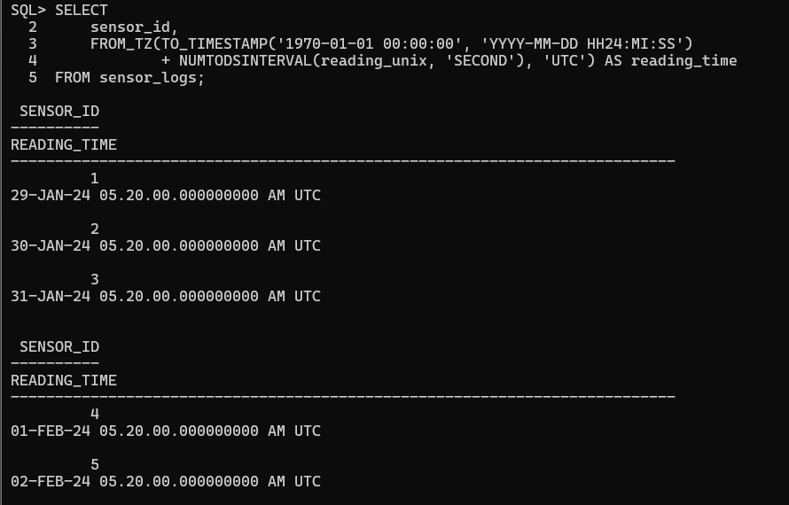

**MySQL:**

SELECT sensor_id, FROM_UNIXTIME(1706505600) AS reading_time

FROM sensor_logs;

**Why?**

● Converts 1706505600 (Unix timestamp) into a **readable date-time format**.

**Example Output:**

|  |  |
| --- | --- |
| **sensor_id** | **reading_time** |
| 101 | 2025-01-29 12:00:00 |

## 4⃣ Marketing Analytics: Extracting Month and Year from Dates

**Scenario:** A company wants to analyze customer purchases by **month and year**.

**Oracle (SQL*Plus):**

SELECT customer_id, purchase_date,

TO_CHAR(purchase_date, 'Month') AS purchase_month,

TO_CHAR(purchase_date, 'YYYY') AS purchase_year

FROM purchases;

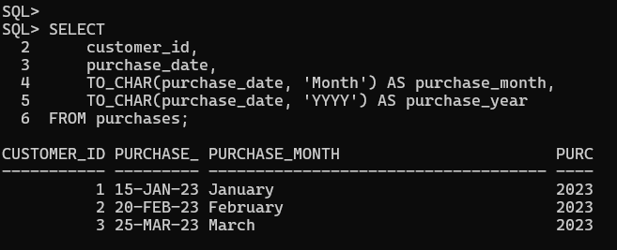

**MySQL:**

SELECT customer_id, purchase_date,

DATE_FORMAT(purchase_date, '%M') AS purchase_month,

DATE_FORMAT(purchase_date, '%Y') AS purchase_year

FROM purchases;

**Why?**

● Uses TO_CHAR() (Oracle) and DATE_FORMAT() (MySQL) to extract **month and year** from a **purchase date**.

**Example Output:**

**customer_id** **purchase_date** **purchase_month** **purchase_year**

501 2025-01-29 January 2025

## 5⃣ Data Migration: Converting String Dates into Proper Date Format

**Scenario:** A company migrating old **CSV data** where dates are stored as strings (DD/MM/YYYY).

**Oracle (SQL*Plus):**

SELECT TO_DATE('29/01/2025', 'DD/MM/YYYY') AS formatted_date

FROM dual;

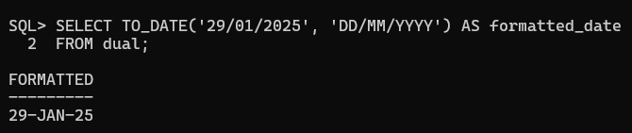

**MySQL:**

SELECT STR_TO_DATE('29/01/2025', '%d/%m/%Y') AS formatted_date;

**Why?**

● Converts 29/01/2025 (string) into a **date type** in Oracle (TO_DATE()) and MySQL (STR_TO_DATE()).

**Example Output:**

|  |
| --- |
| **formatted_date** |
| 2025-01-29 |

## 6⃣ Logistics & Delivery: Calculating Expected Delivery Time Based on Distance

**Scenario:** Estimate delivery **ETA** based on **distance traveled** and **average speed**.

**Oracle (SQL*Plus):**

SELECT order_id, distance_km,

ROUND(distance_km / 60, 2) AS estimated_hours

FROM deliveries;

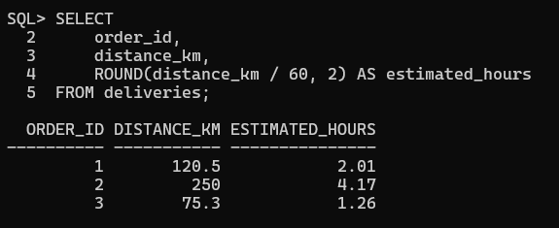

**MySQL:**

SELECT order_id, distance_km,

FORMAT(distance_km / 60, 2) AS estimated_hours

FROM deliveries;

**Why?**

● Divides distance_km by 60 km/h (average speed).

**Example Output:**

|  |  |  |
| --- | --- | --- |
| **order_id** | **distance_km** | **estimated_hours** |
| 1001 | 120 | 2.00 |

## 7⃣ Social Media Analytics: Converting Post Dates into Readable Formats

**Scenario:** A social media platform needs to display post timestamps **beautifully**.

**Oracle (SQL*Plus):**

SELECT post_id, TO_CHAR(post_date, 'Month DD, YYYY HH24:MI')

AS formatted_date FROM posts;

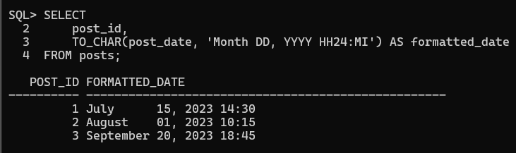

**MySQL:**

SELECT post_id, DATE_FORMAT(post_date, '%M %d, %Y %H:%i') AS formatted_date FROM posts;

**Why?**

● Converts **date into a social-media friendly format**.

**Example Output:**

|  |  |
| --- | --- |
| **post_id** | **formatted_date** |
| 555 | January 29, 2025 14:35 |

## Summary Table

|  |  |  |
| --- | --- | --- |
| **Scenario** | **Oracle (SQL*Plus)** | **MySQL** |
| Convert prices to INR | TO_CHAR(price,  'L99,999.99') | FORMAT(price, 2) |
| Detect fraud based on time | EXTRACT(HOUR FROM transaction_time) | HOUR(transaction_tim e) |
| Convert Unix timestamp | FROM_TZ(TO_TIMESTAMP(  ...), 'UTC') | FROM_UNIXTIME(...) |
| Extract month  & year | TO_CHAR(date, 'Month  YYYY') | DATE_FORMAT(date,  '%M %Y') |
| Convert string to date | TO_DATE('29/01/2025',  'DD/MM/YYYY') | STR_TO_DATE('29/01/2 025', '%d/%m/%Y') |
| Estimate delivery ETA | ROUND(distance_km /  60, 2) | FORMAT(distance_km /  60, 2) |
| Format social media timestamps | TO_CHAR(post_date,  'Month DD, YYYY  HH24:MI') | DATE_FORMAT(post_dat e, '%M %d, %Y %H:%i') |